Kingswood Trumpet

April 2024 Publication of
Kingswood United Methodist Church
302-738-4478
300 Marrows Road
Newark, DE 19713
kingswoodumc@outlook.com
www.kingswoodhope.com
Facebook – Kingswood United Methodist church – Delaware

From the Desk of Pastor John Hornberger
Last month we talked about the book of Ecclesiastes, a book written by king Solomon. For our lesson today we read about God planting. God not only sows, tends, and does the harvest but in the harvest plants “forever.” When a farmer plants he or she plants in faith. That person expecting a harvest, and it plants expecting and God expects too.
But look at chapter 3 verse 11, “He has planted eternity in the human heart! God planted in our hearts eternity! Again check the point God took us, saved us, died in our place, rose again so that we will raise again and live forever. Our hearts, not the human heart, but the heart, which is our emotions, our wills, our spirit, our beings and minds to live forever.
In chapter 3 we see there that God wants us to be happy, and enjoy life, eat and drink happily, and then God gives us the “fruit or tools” to enjoy life. There is a song that I really like a lot; “We are not alone,” no folks we are not alone we are never alone.
Thanks be to God! (Forever alone)

Ramp & Chairlift are available for
Sanctuary Accessibility

Prayer

Thanks be to you, O God,
for this hour of worship and wonder
for this day to rest and renew
for this time of peace and pardon.
Accept our glory and praise,
for you are the source of our salvation,
your are the instructor of righteousness,
your are our God,, and we are your people,
through Jesus Christ your Son.
Amen
-Arlene M. Mark

Kingswood has a social media presence:
Website is: www.kingswoodhope.com
Facebook is:
Kingswood United Methodist Church - Delaware

Copyright License ^{R} 22114298
+CCLI Streaming Plus License TM 22114308
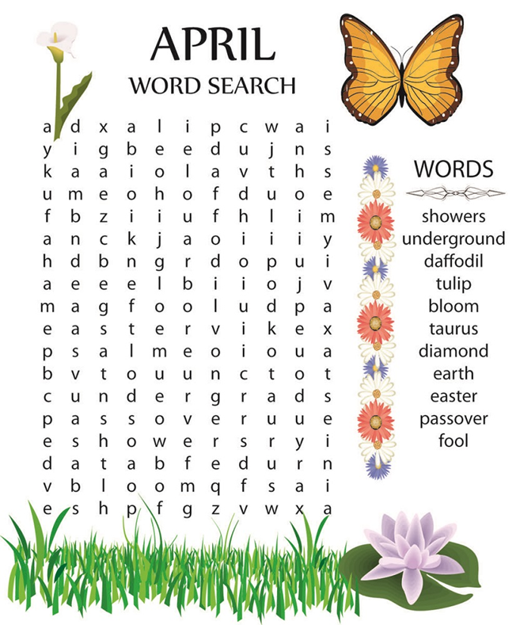
March Activities
for Young Disciples
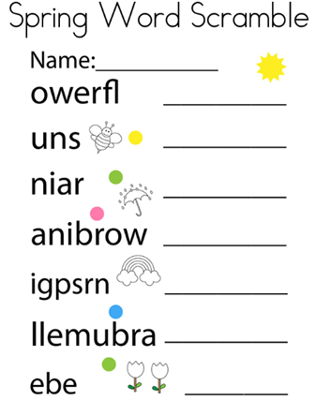
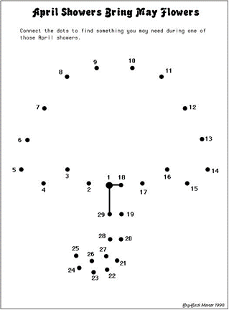

Worship Attendance Statistics
Date | Worship Attendance
02/25/2024 | 44
03/03/2024 | 44
03/10/2024 | 42
03/17/2024 | 39

Bible Study:
Bible Study at 10:00 am in the Gathering Room

Choir Practice in the Sanctuary at 7:00pm.
Please come and join us we always have fun learning new songs and even singing old songs we know.
All are welcome no experience necessary.
Choir Director, Lorraine Rolfe

Adult Sunday School
Adult Sunday School meets in
The Gathering Room on Sundays from 9:50-10:50 AM.
Our next Adult Sunday School series is entitled "Prophets and Kings of Israel."
Come and explore the turbulent history of Israel's prophets and kings. Learn from their stories how to build you own devotion to God!

Thank You
Kingswood would like to thank Ogletown Baptist Church for the great job they did repainting our Fellowship Hall.

Happy Anniversary

Roberta & Charles Collins 4/17

Happy Birthday

Mary Kreps 04/01
Dawn Crotsley 04/01
Matthew Pragg 04/02
Jessica Altevogt 04/03
Laura Sievert 04/05
Roberta Collins 04/20
Scott Westbrook 04/20
Kathy Schaffer 04/26

Our Mission
To prevent and end homelessness for families by engaging volunteers, donors, and the faith community.

Our Vision
We envision a community in which every family has a home, a livelihood, and the resources for lasting independence.
Family Promise of Northern New Castle County is in the business of transforming the lives of families experiencing homelessness because every child deserves a home. Families are sheltered at the Hospitality Center on Mill Creek Road. Guests receive hospitality and meals from the congregation’s members and other volunteers. Recently, Kingswood UMC made a $500. donation to Family Promise as part of our annual T-Mobile tithing based on the 2023 rental income received.
During the week of March 24, Kingswood volunteers will coordinate with White Clay Creek Presbyterian to provide evening meals for the guests. We often donate crocheted and knitted blankets for the children when we meet them. If you would like to help prepare and/or serve a meal talk with Alice Stiner or Linda Wolfer.

Family Promise Impact for 2023: 2,100 volunteers 45 congregations
134 families served
463 parents and children housed
10,000+ hours served
22,000 + meals provided
93 % positive outcomes
days to housing = 97

The Mission Committee:
We are very grateful for all the Food Closet Donations.
Donations will be accepted in the “Food Closet Basket” on any Sunday in the Narthex.
Your donations will be a blessing to those in need.
The following items are packed into every food bag when a request is made:

macaroni & cheese elbow macaroni
rice cereal
tuna dry milk
spaghetti spaghetti sauce
peanut butter jelly
canned fruits canned vegetables
Spam potatoes
dry soup soup
canned ham beef stew
hash sugar packets
paper towels toilet paper

ATTENTION:

When we have inclement weather listen
to WDEL FM 101.7
AM 1150
or go to WDEL SnoWatch/wdel.com
Website:
www.kingswoodhope.com
or
Facebook:
Kingswood United Methodist Church-Delaware

April 26, 2024 & May 24, 2024
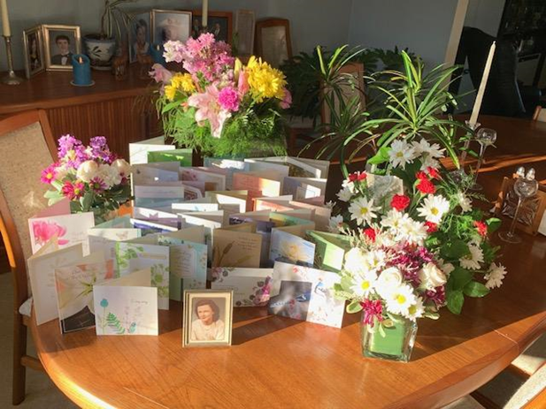

To our Dear Friends at Kingswood:
Laura and I thank you for the cards and flowers you sent us in remembrance of my Mother, Elizabeth Todd.
Your expressions of love were beautiful and deeply appreciated. On Dr. Cook’s “Walk with the King” radio broadcasts, he used to point that the Psalmist said we walk through the valley; God doesn’t just take us there and leave us. While she was in the hospital this Fall, Mom asked me if God would take care of her.
I replied that he certainly would and I know he did.
Thank you again for your support at this time.
Allen Sievert
Timeline for 2024 - upcoming events
- April 2, 2024 – 10am Bible Study, Gathering Room
- April 2, 2024 - 7pm Choir Practice
- April 7, 2024 - 2nd Sunday of Easter
- April 9, 2024 – 10am Bible Study in room 207
- April 9, 2024 - 10am Krafters in the Gathering Room
- April 9, 2024 - 7pm Choir Practice
- April 10, 2024 - We Serve Hope Dining Room
- April 14, 2024 – Native American Sunday
- April 15, 2024 - Trumpet Articles Due
- April 15, 2024 - 10am Missions in Gathering Room
- April 15, 2024 - 7pm AD Council -Zoom
- April 16, 2024 - 10am Bible Study, Gathering Room
- April 16, 2024 - 7pm Choir Practice
- April 21, 2024 - 4th Sunday of Easter
- April 22, 2024 - 7pm Finance Meeting - Zoom
- April 23, 2024 - 10am Bible Study, Gathering Room
- April 23, 2024 - 7pm Choir Practice
- April 26, 2024 - 11:30 – 1:30 HOPP Distribution
- April 28, 2024 - 5th Sunday of Easter

SUNDAY | MONDAY | TUESDAY | WEDNESDAY | THURSDAY | FRIDAY | SATURDAY
 | 1 HDR  7pm –  Hope Meeting Zoom | 2 HDR  10am – Bible Study  Gathering Room  12-1 - Food Closet  7pm- Choir Practice | 3 HDR | 4 HDR  6:30pm –  Friends of Bill W. (AA) | 5 HDR  12-1 - Food Closet | 6
7 2nd Sunday of Easter  9:50am –  Sunday School  11am -  Traditional Worship | 8 HDR  7pm -Trustee Meeting  Zoom | 9 HDR  10am -Kingswood Krafters  Gathering Room  10am – Bible Study  Room 207  12-1 - Food Closet  7pm- Choir Practice | 10 HDR  9:30 am –Kingswood Serves Hope | 11 HDR  6:30pm –  Friends of Bill W. (AA) | 12 HDR  12-1 - Food Closet | 13
14 3rd Sunday of Easter  9:50am –  Sunday School  11am -  Traditional Worship  Native American Sunday | 15 HDR  10am – Missions in  Gathering Rm  7pm – AD Council  Meeting Zoom  Trumpet Articles Due | 16 HDR  10am – Bible Study  Gathering Room  12-1 - Food Closet  7pm- Choir Practice | 17 HDR  11:30am – Retreads at  Green Turtle by hospital | 18 HDR  6:30pm –  Friends of Bill W. (AA) | 19 HDR  12-1 - Food Closet  HOPP  11:30am – 1:30pm | 20
21 4th Sunday of Easter  9:50am –  Sunday School  11am -  Traditional Worship | 22 HDR  7pm – Finance Meeting | 23 HDR  10am – Bible Study  Gathering Room  12-1 - Food Closet  7pm- Choir Practice | 24 HDR | 25 HDR  6:30pm –  Friends of Bill W. (AA) | 26 HDR  HOPP  11:30am – 1:30pm  12-1 - Food Closet | 27
28 5th Sunday of Easter  9:50am –  Sunday School  11am -  Traditional Worship | 29 HDR | 30 HDR  10am – Bible Study  Gathering Room  12-1 - Food Closet  7pm- Choir Practice

Our District Superintendent

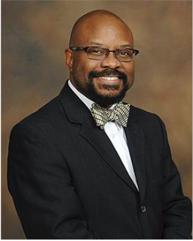
Rev. Joseph Archie
Delaware
District Office
900 N Washington St Wilmington, Delaware 19801
Website: delawaredistrictumc.org
Phone: (302) 302-655-8873
e-mail:
delawaredistrictumc@gmail.com
The Delaware District Office
is open:
Monday thru Thursday
8:00 a.m. – 2:00 p.m.
Our Bishop
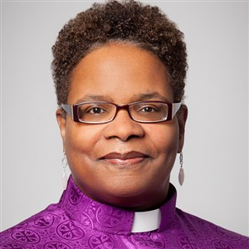
Rev. Latrelle Easterling
Peninsula-Delaware
Conference
Bishop Felton Edwin May Resource Center
139 N. State Street,
Dover, DE 19901
Website: www.pen-del.org
Phone: 302-674-2626
Toll Free: 1-877-736-3351
The Peninsula-Delaware Conference office is open:
Monday thru Thursday
8:30 a.m. - 4:30 p.m.
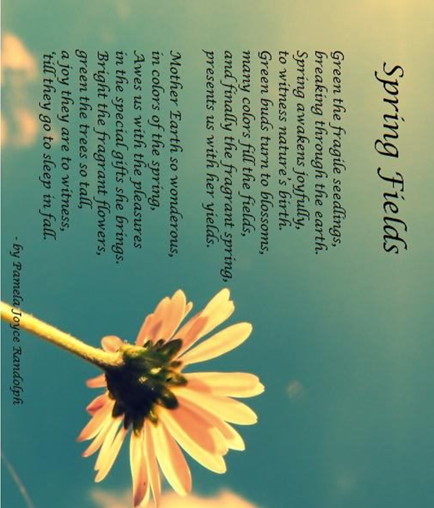
A Monthly Publication of
Kingswood United Methodist Church
300 Marrows Rd.
Newark, DE 19713
Issue 2024- 03 a
Facebook –
Kingswood United Methodist church - Delaware
www.kingswoodhope.com
kingswoodumc@outlook.com

